How To Make a Selection Using ACE Interface
At My Project - Active page
- Create Project
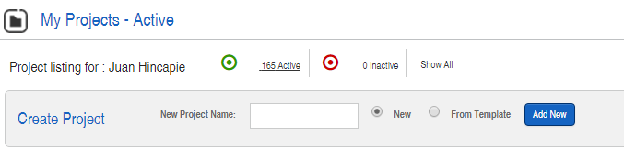
  - New
    - It opens Project information page. Fill out required fields.
    - Check if this project is going to be used as a template for future projects.
  - From template
    - If a template was created, choose the one that fits your application.
    - An existing project can become a template from the Project information page.

- Select schedule for the created project.
At Project Schedule page
- Select product family, category, model and quantity. Click Add
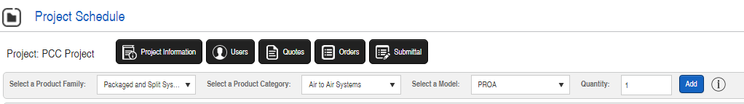
At Package and Split systems page
- Introduce Design Inputs using information from design engineer schedule
  - Tagging and quantity
  - Product category: It came from step 3 but it can be updated here
  - Model: It came from step 3, but it can be updated here.
  - Unit size: Auto default (recommended). Unit size can be chosen to select an specific cooling capacity.
  - Unit voltage: Choose as per application requirements
  - Cooling type: It defaults depending on the Product Category selection
  - Heating type (it is a good practice to input Total Airflow so heating calculations are accurate):
    - Hot water. Hot Water input box appears. Fill out required information
    - Steam. Applications need to select this option.
    - Electric heat. Electric coil input box appears.
    - Gas heat. Gas furnace input box appears. Use available modulation as per table 1
Available modulation for Gas heat
Furnace Options
Furnace MBH Input | Furnace MBH Output | Heaters | Stages | Modulation
75 | 60 | (1) 75 | 2 | 5:1
100 | 80 | (1)100 | 2 | 5:1,10:1
150 | 120 | (1)150 | 2 | 5:1,10:1
200 | 160 | (1)200 | 2 | 5:1,10:1
250 | 200 | (1)250 | 2 | 5:1,10:1
300 | 240 | (1)300 | 2 | 5:1,10:1
350 | 280 | (1)350 | 2 | 5:1,10:1
400 | 320 | (1)400 | 2 | 5:1,10:1
500 | 400 | (1)500 | 2 | 5:1,10:1
600 | 480 | (1)600 | 2 | 5:1,10:1
200 | 160 | (2)100 | 4 | 10:1
300 | 240 | (2)150 | 4 | 10:1
400 | 320 | (2)200 | 4 | 10:1
500 | 400 | (2)250 | 4 | 10:1
600 | 480 | (2)300 | 4 | 10:1
700 | 560 | (2)350 | 4 | 10:1
800 | 640 | (2)400 | 4 | 10:1
1000 | 800 | (2)500 | 4 | 10:1
1200 | 960 | (2)600 | 4 | 10:1
800 | 640 | (4)200 | 8 | 20:1
1000 | 800 | (4)250 | 8 | 20:1
1200 | 960 | (4)300 | 8 | 20:1
1400 | 1120 | (4)350 | 8 | 20:1
1600 | 1280 | (4)400 | 8 | 20:1

Table 1

  - Heat Recovery. Energy Conservation Wheel appears. Fill out accordingly.
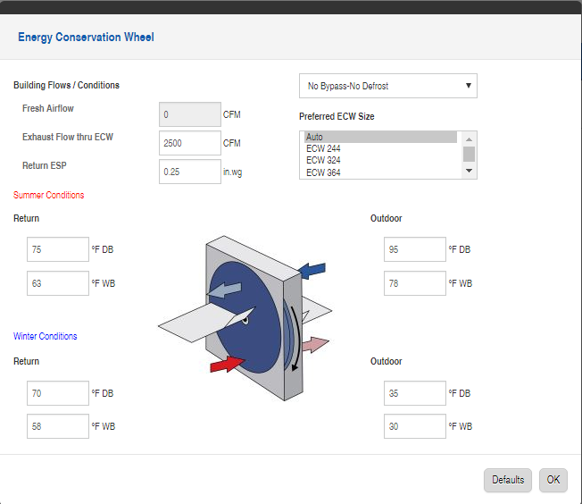
Wheel performance will override the entering air conditions information at the DX – Air cooled data
ECW options are specified here
  - Total Airflow. This will be used as fresh airflow in the ECW calculations for PROA and the heating performance calculations.
  - Outside airflow. Specify the Fresh air airflow for PRRA/PROM
  - External SP. As per engineer’s schedule.
  - Fan type. Auto default (recommended). But Airfoil or Backward Incline options available. Backward incline is cheaper than Airfoil
  - Motor Type. Auto default. OPD (Comefri fans), ECM (Rosenberg fans), TEFC (Comefri fans)
    - Selecting ODP fan will make all the fans, supply and exhaust to be Comefri fans. These are cheaper than ECM fans.
  - Max HP. If motor HP needs to be limited to certain value.
  - Altitude. For altitude sensitive applications.

At cooling capacity box for DX – Air cooled or heat pump (air source)

  - Optimize for price check box.
Having this box checked will optimize the selection to provide the less expensive option that matches the required leaving air conditions. Refrigeration options (Sub cooling and reheat) will automatically be included if they provide a better price. Preliminary pricing will show for each selection option for further analysis. This is a good tool to determine what a more expensive unit can provide or a less expensive unit will compromise.
If the box is not checked manual input is required for refrigeration options (at features and options input box) and number of rows. This resemble the old way of doing selected and PR unit selection rules need to be applied (see PR selection guideline document)
  - Desired min coil LAT. For optimized selections the program will ask a range where the leaving air conditions out the coil should be. This represents the lower limit DP for those conditions.
  - Desired max coil LAT. For optimized selections the program will ask a range where the leaving air conditions out the coil should be. This represents the higher limit DP for those conditions.
  - Desired unit LAT. This will determine if reheat is needed. The program will automatically calculate if single or dual hot gas reheat will be included in the selection. If this temperature input is similar or equal to the leaving air conditions out of the coil will mean that no reheat is needed and the selection options will reflect that.
  - Ambient. Outdoor air temperature.
These will be overridden if ECW is selected
  - EAT DB. Entering Air Temperature Dry Bulb.
  - EAT WB. Entering Air Temperature Wet Bulb
  - Rows. 6 or 4 row options available. 6 row coil must be chosen for units 036,048,060
  - Reheat type. Options are staging or modulating hot gas reheat.
At cooling capacity box heat pump (water source)
  - Optimize for price check box applies the same as DX air cooled systems
  - Entering Fluid Temp.
These will be overridden if ECW is selected
  - EAT DB. Entering Air Temperature Dry Bulb.
  - EAT WB. Entering Air Temperature Wet Bulb
  - Rows. 6 or 4 row options available. 6 row coil must be chosen for units 036,048,060
  - Fluid flow. 3 GPM per ton is normally recommended unless otherwise is noted in schedule.
  - Fluid Type. Options: Water, Ethylene, Propylene
  - Volume glycol. Percentage.
  - EAT DB. Entering DB for heating performance
  - Entering Fluid Temp for heating performance
At cooling capacity box air handler (chilled water)
These will be overridden if ECW is selected
  - EAT DB. Entering Air Temperature Dry Bulb.
  - EAT WB. Entering Air Temperature Wet Bulb
  - Entering Fluid Temp.
  - Calculation method. Options: Leaving air temp or capacity
  - Target unit LAT DB and WB
  - Rows. 6 or 4 row options available. 6 row coil must be chosen for units 036,048,060
  - Filter method. Options: Fluid flow or Leaving air temperature
  - Fluid Type. Options: Water, Ethylene, Propylene
  - Volume glycol. Percentage.
Additional selection rules.
Cabinet | MAX Blower Size | MAX ECW | Max Furnace Heating Capacity | Max Furnace XL Cabinet
A Cabinet  450-2500 CFM | GHKM400  355,315,280  (ECM Motors ONLY) | ECW364  244,324 | 100 MBH Furnace  (30 KW Electric) | N/A
B Cabinet  2000-4000 CFM | GHKM450  450,355  ANPL16  10,11,12,14,16 | ECW424  244,324,  364 | 200 MBH Furnace  (100 KW Electric) | (2)200 MBH
C Cabinet  3000-7000 CFM | GHKM450  ANPL20  14,16,18 | ECW486  324,364,  424,484 | 300 MBH Furnace  (100 KW Electric) | (2)400 MBH
D Cabinet | 2-GHKM450  2-355, 450, | ECW706  484,486, | 400 MBH Furnace  (150 KW Electric) | (2)600 MBH
6000-11000 CFM | ANPL25 | 544,606,  664,666
 | 22,20,18
E Cabinet  8000-20000 CFM | (2) ANPL20  (1) ANPL25 | ECW8412 | 600 MBH Furnace  (150 KW Electric) | Vertical Supply  (4)400 MBH
 |  |  | (No horizontal supply available) | Horizontal Supply(EXL Only)  (2)600 MBH

- Features and Options. Click Edit to open input window.
Some of these options will affect the selection performance so if they are changed a new selection is required to be performed. Others do not affect the selection, so they can be chosen in the pricing page to procure a price. We recommend editing the ones that affect performance in the selection section and the ones that not leave them for the pricing page. However all can be chosen beforehand. Options that are NOT modified in the selection or pricing page will default to none option.
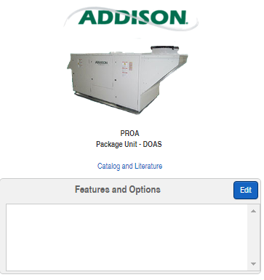
  - ALC Ship With options. It does NOT affect selection.

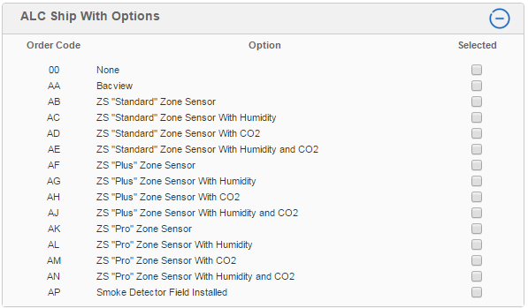

  - CAV/ VAV. Define constant volume of Variable volume operation. It will determine if DPT options will be shown in pricing page.
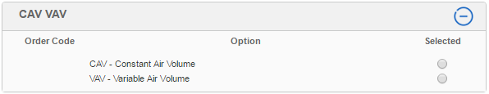
  - Control Options. It does NOT affect selection.

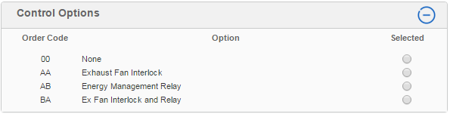

  - Disconnect. It does NOT affect selection. This should be chosen based on the Maximum Fuse Size MFS value calculated in the selection.
    - The disconnect shall be sized to the next available size above the MFS value from the selection, so select in the Pricing page options, once MFS value is known.
    - In the pricing page the MOCP value from the selection will be shown so the correct disconnect can be chosen.
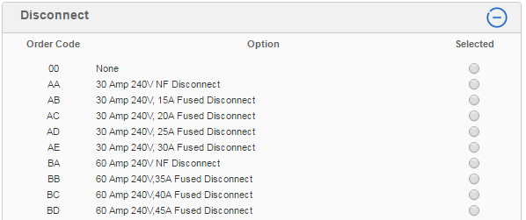
more

  - Evaporator Motor Type. It does NOT affect selection.
    - ODP and TEFC options shall be used only for airfoil and Backward inclined fans (Comefri fans)
    - ECM options shall be used only backward inclined ECM fans (Rosenberg fans).
Do not apply conflicting options as they will cause pricing errors.

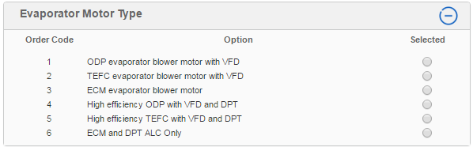
Apply to VAV systems
Apply to CAV systems

  - Exhaust Blower options. It does NOT affect selection.
If power exhaust is needed, select the option required and the Exhaust Fan Requirements will appear to input airflow and External Static pressure. If an ECW is being used, the information for the exhaust fan was already introduced in the Energy Conservation Wheel input box.
It is better not to select an option here and wait until the selection provides the fan. Then the right options can be selected.

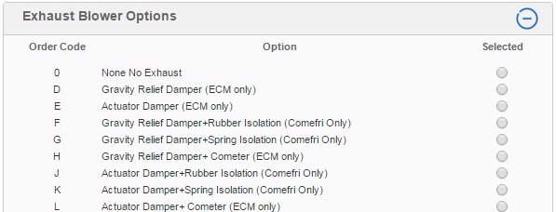
more

  - Exhaust/Return Blower Motor Type. It does NOT affect performance.
    - ODP and TEFC options shall be used only for airfoil and Backward inclined fans (Comefri fans)
    - ECM options shall be used only backward inclined ECM fans (Rosenberg fans).
Do not apply conflicting options as they will cause pricing errors.

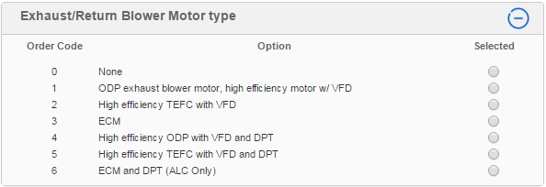
Apply to VAV systems
Apply to CAV systems

  - Maintenance options. It does NOT affect selection.

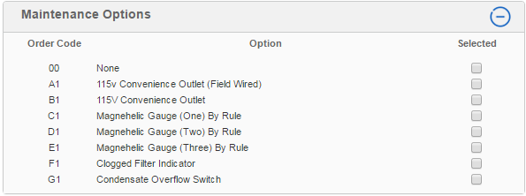

  - PR Controls. It does NOT affect selection.
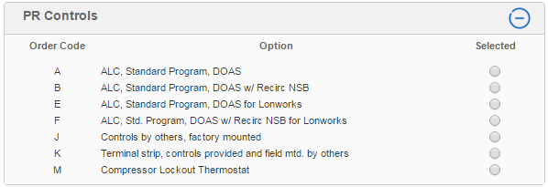

  - PR Refrigeration controls. IT AFFECTS SELECTION
(CRITICAL FOR PROPER SELECTION AND PRICING)
These options shall be chosen having in mind the Product Category and the Compressor Type.
All units with compressors should have a head pressure control mechanism.

      - Units 96 MBH or below should use the single circuit option.
      - Units 120 MBH and above should use the dual circuit option.

    - When a regular scroll compressor is planned to be used, Hot gas bypass is required for 100% OA applications. Recommended but not required for mix and RA applications.
    - When digital scroll compressors are used, HGBP is not required and shouldn’t be selected.
    - Hot gas reheat can be staged or modulating, single or dual circuit. Choose according to the project requirements.
    - Liquid sub cooling switchable all circuits can be chosen to improve the unit performance and efficiency. This option is normally paired with a Single Circuit HGR option for 100% OA applications. It is not used in RA applications or air source heat pumps 300MBH and above.

These options also affect the total static pressure of the system.
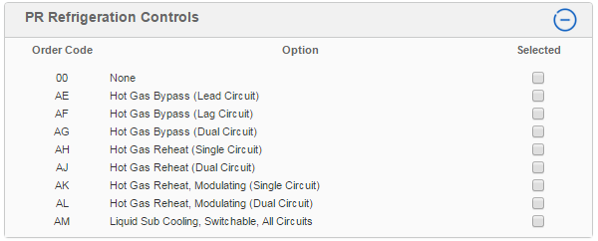

  - PR Supply Blower Options. It does NOT affect selection.
It is better not to select an option in the selection page and wait until the selection provides the fan. Then the right options can be selected in the pricing page if pricing is required.

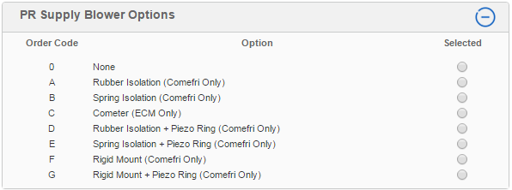

  - Safety controls. It does NOT affect selection.

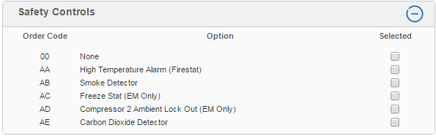

  - Cabinet options. It does NOT affect selection. However, it needs to be consistent with the application intent. It can cause conflict with the Ventilation and controls options and PR Controls if not chosen properly. Example: If DOAS controls are chosen, do not choose Return to the unit or Ventilation with RA dampers.
    - It is mandatory that applications with energy recovery are provided with supply AND return to the unit.

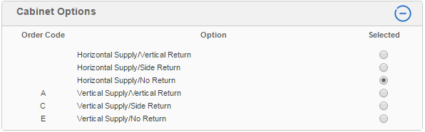

  - Compressor type. It does NOT affect selection. It will determine the options that should be chosen in the PR Refrigeration Controls. Hot gas bypass is mandatory for DOAS with regular scroll compressor.

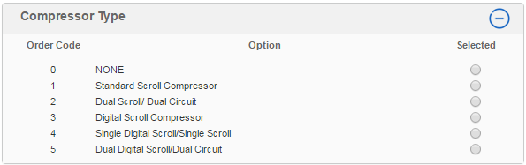

  - Ventilation & Controls. IT AFFECTS SELECTION. However, it needs to be consistent with the application intent. It can cause conflict with the Cabinet options and PR Controls if not chosen properly. Example: Do not choose RA dampers for DOAS applications or cabinets without RA inlet.

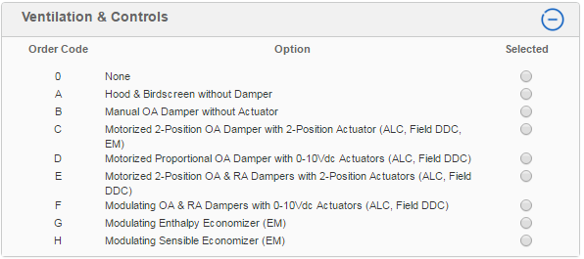
Only available if Remote thermostat or Compressor lockout were chosen in PR controls

PR Controls  Vs.  Airflow Orientation | A = Vertical Supply and Vertical Return | B = Horizontal Supply and Vertical Return | C = Vertical Supply and Side Return | D = Horizontal Supply and Side Return | E = Vertical Supply and No Return | F = Horizontal Supply and No Return
A = ALC, Standard Program, DOAS
B = ALC, Standard Program, DOAS w/ Recirc NSB
C = ALC, Standard Program, Recirc
D = ALC, Standard Program, w/ Econo., Enthalpy
E = ALC, Standard Program, DOAS for Lonworks
F = ALC, Std. Program, DOAS w/ Recirc NSB for Lonworks
G = ALC, Std. Program, Recirc for Lonworks
H = ALC, Std. Program, w/ Econo., Entpy. for Lonworks
J= Controls by others, factory mounted
K= Terminal strip, controls provided and field mtd. by others
L= Remote Thermostat
M= Compressor Lockout Thermostat
N = ALC, Standard Program, w/ Econo., Sensible
P = ALC, Std. Program, w/ Econo., Sens. for Lonworks

Economizer for 100% OA units: It is included in the standard SOO. Refrigeration system will turn off and only fans will work to introduce 100% OA when conditions are cold and dry enough.

  - Filters. IT AFFECTS SELECTION.
It is recommended to choose this option as it might change the total static pressure for the fan calculation.
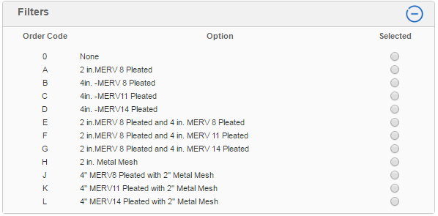

  - Harsh Environment – Package. . It does NOT affect selection
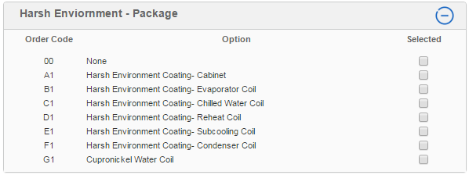

  - Curbs. Select this in pricing page once the selection is defined and the proper curb is filtered and selectable.

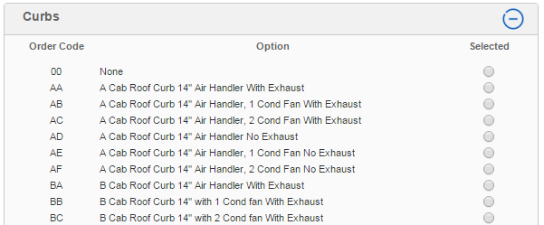

How To Price a PR unit using ACE Interface
- A valid selection needs to have been created from the selection page and registered in the project schedule. Select the $ sign to go the Pricing page.
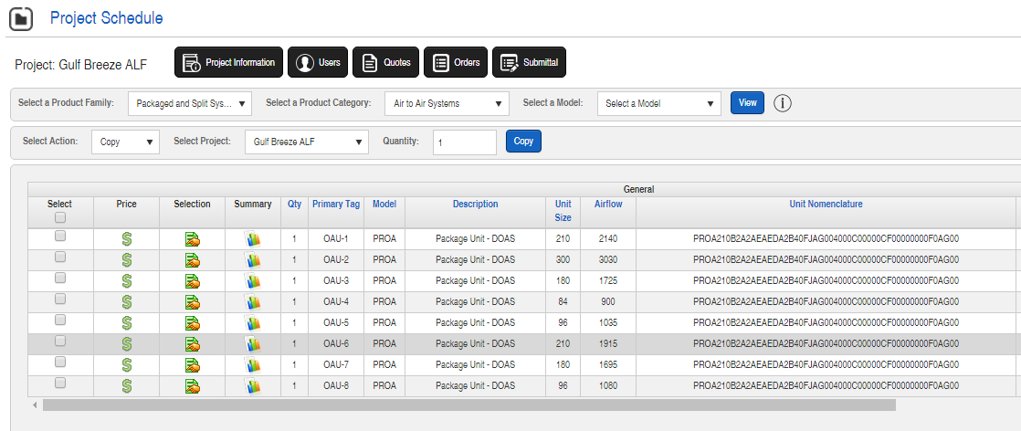

- At the Pricing page, all the locked data from the selection and selected options will populate the fields.
- Some of the fields can be changed in the Pricing page if they don’t affect the selection. If the item cannot be changed, it means it is attached to the selection output and only doing a new selection will change the data.
- Features and options can be changed also at this page using the Edit button. All the options chosen in the Selection page transferred to this list.
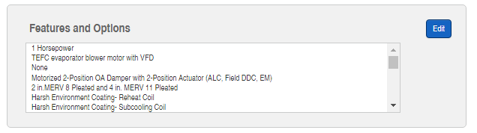

- Once all the options and information is input, click the Save button. The code string (unit nomenclature) should update itself for the latest configuration and no underscores should be present. Each underscore means that something is missing, wrong or presenting some conflict so the input information needs to be reviewed and revised.

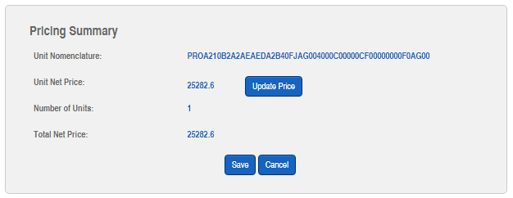

- Click Update price button. Price should appear after a few seconds.

Best practices:
- Do the selection with the minimum required information and adjust options in the pricing page.
- Information from the selection is needed to choose the proper options (curbs, disconnects, etc) so leave these options to be finalized in the pricing page.
- Choose filters, ventilation, refrigeration options in the Selection page. They affect performance.
- If needed change options to see how the price changes. This will provide additional information to have an educated conversation with engineers or owners about the possibilities the Addison can offer.
- Call applications for support. Don’t share the project. The application team can access all projects. You just need to reference the project name.
- Ask application for a configuration or price review if needed.
How to get better pricing:
- Select 4 row coils instead of 6 row coils.
- Use sub cooling and single circuit reheat combination to improve performance and reach desired leaving air conditions with a lower capacity compressor. This is done automatically if the option “Optimize for price is checked.
- Use regular scroll” compressor. For 100% OA applications use regular scroll/ digital scroll compressor combination. Remember for 100% OA units always use hot gas by pass if regular scroll compressor is chosen.
- Allow higher leaving air conditions. Discussion with engineer might be required to allow this change.
- Use backward incline (ANPL) fans instead of airfoil fans (ANPA). Also ANPL and ANPA fans are cheaper than ECM fans.

